MUTABLE = It means changeable.
IMUTABLE = It means does not change.
Concept-1 :-
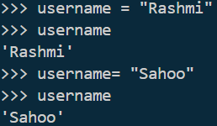
In this picture first I stored one string and print.
After the first user name create another username then print. Two username print different name.
But string is immutable. How it is change ?
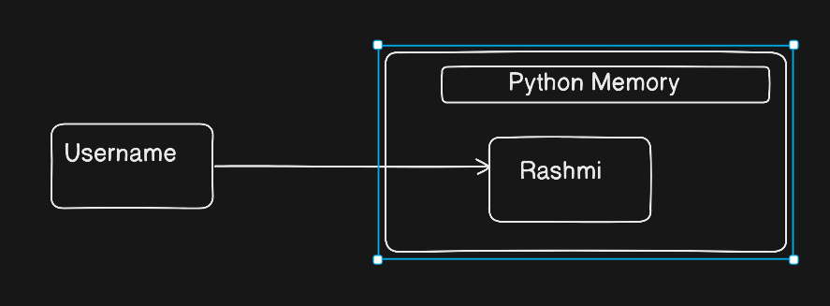
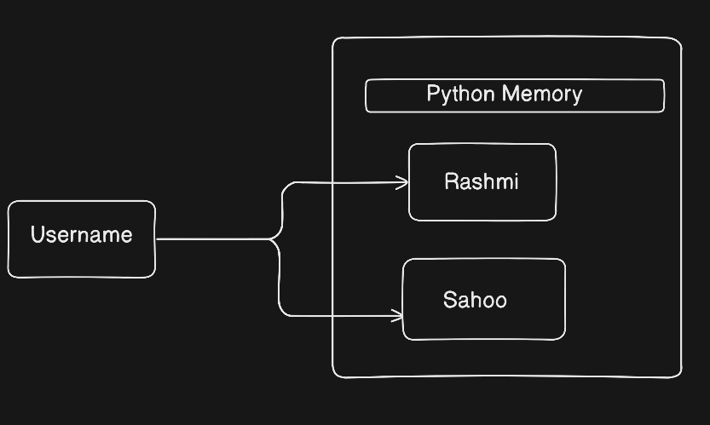
In this picture store the Rashmi in Username.

One user name create the two String.1st create Rashmi and 2nd create Sahoo.
After the create of second string username give the reference of second one. Username cannot give the reference of 1st one.
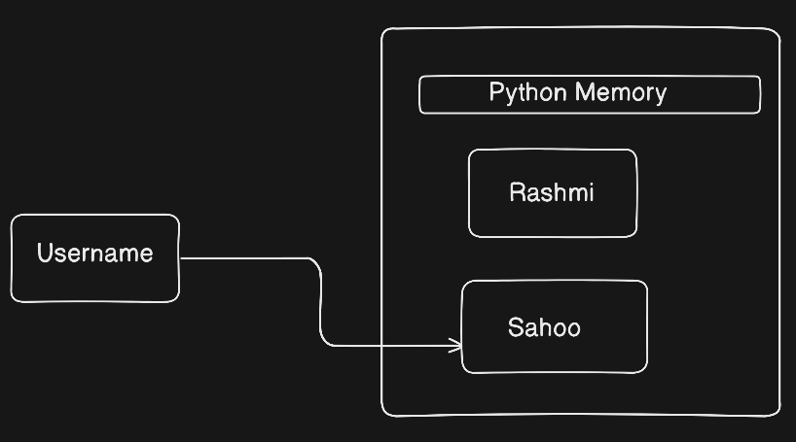
1st one is not deleted . 1st one is present and 2nd one is present . only the username give the reference of 2nd one. Stile 1st one is present.

Concept -2
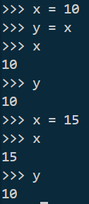
In this picture see x value give, y value is x value, after that print x and print y. Same value is come in x and y.
But another time give the x value, x is print 15 but why y is not print 15 ?
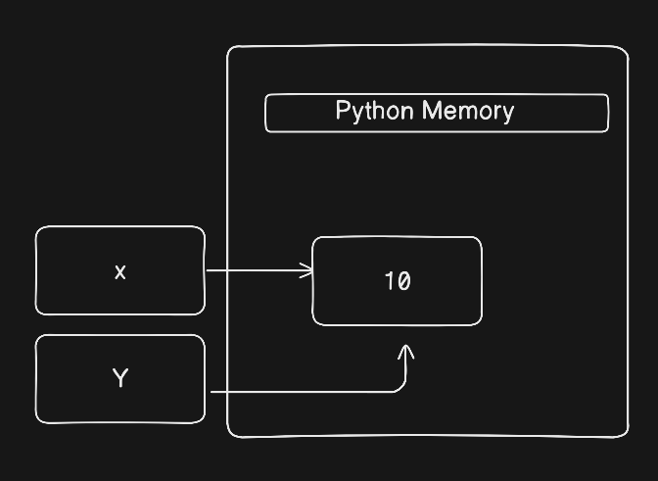
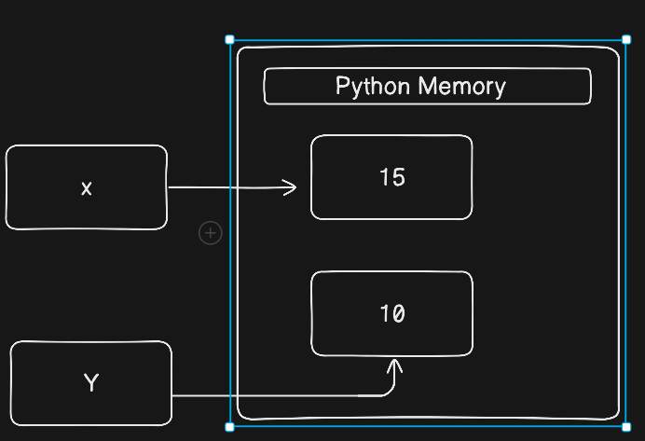
In this picture x give the reference of 15 but y give in 10. I write y = x for x=10 . If I again write y =x . then y give the reference of 15. This thing for y show the 10 and x=15 .

